Holy Spirit Parent Council Meeting Minutes
May 27, 2022
Attendance: Aoife Cahill, Carrie Belisle, Ted Paszek Kim Pennok, Jason Duniec, Jenelle Potyondi,
Call meeting to Order and Opening Prayer
Jason called the meeting to order at 6:35pm
- Opening Prayer led by Carrie Belisle

- Approval
  - Approve today’s agenda: Kim P. – First; Carrie – Second; carried
  - Approve April meeting minutes: Kim P. – First; Carrie – Second; carried
- Teacher Presentation Ms. Quinlan {ESC Team}

Classroom Updates:

PreK/K - This month, we have continued to do our letters of the week, talked about our likes and interests, and expanded on what makes us unique. We have created a campsite in our classroom, which has been fun for role-playing and dramatic play. We have also talked about our individual goals for school and how we can always work on making good choices. This week we started a word retrieval task in circle time, where students complete a sentence given in an exciting way. Lastly, we are doing soapstone butterflies this week, which we are very excited about.

Kindergarten: What can you see? Taste? Touch? Smell? Hear? We have been learning all about our senses this past month, using them to explore and interpret the world we live in. We celebrated our Mom’s last week with a very special tea party in their honour. It was so lovely to be able to gather as a kindergarten family, in person!! We put on a little performance, showered them with gifts and enjoyed a little snack. It was two wonderful afternoons! It is hard to believe we only have about 12 days of kindergarten left for each class! Where did the time go?

Grade 1: The Grade Ones spent an exciting day at Farmer Sarah’s farm. It was our first out of school field trip and first time on the bus! We saw cows, horses, chickens, turkeys, pigs and goats. We got to hold baby chicks and pet the horses. Farmer Sarah brought in some eggs for us to hatch at school. On May 11th 11 baby chicks hatched! It was very exciting! In June we are going to the Fort Saskatchewan Museum to learn about the Olden Days.

Grade 2: Numerous transitions in grade 2 as Mrs. Peterson left to attend to her health needs and Mrs. Mittelsteadt took over. Also in 2Q, Ms. Quinlan began teaching Pathways four mornings a week and Mrs. Boston and Mrs. Allen took over those morning classes. We are looking forward to our first field trips to the Strathcona Wilderness Centre on May 30th and to the Strathcona Museum on June 14th.

Grade 3: The grade 3 students have enjoyed learning about rocks and minerals this month and enjoyed an in-school field trip with teacher's pet where they got a hands-on look at different rocks and minerals! This month, the grade 3 classes also had the opportunity to visit our school chapel for adoration where they took some special time to pray with Jesus.

Grade 4:
The grade 4 students are enjoying learning about Light and Shadows in science for the months of May and June. St. Theresa and OLPH schools visited with us to learn about their programs and help us learn about the middle school we will attend next year. We are excited to learn some strategies for helping us transition with Miss. B. soon, and we will be going to St. Theresa on June 23, 2022 to see the building in person. Our grade 4 Farewell Mass will be held on June 17, 2022 at OLPH Parish at 10 am.
Upcoming in June, the grade 4s will be creating a soapstone craft for Father’s day.
*There has been a change to the year end activity. Due to an availability issue the movie theatre is not available to us at the end of the year. The grade 4 teachers have chosen to attend 2 programs at the Strathcona Wilderness Centre for the year end activity in place of the movie. A parent letter will be sent at the beginning of June with clarification of farewell and year end field trip.

“Notes” from the Music room:
Our Holy Spirit students sang with the JOY of Jesus in their hearts during our Adoration Mass last Wednesday. It was an amazing feeling being together in the gym again. The children told me after how much they loved singing together and that they have never felt anything like that before. It is powerful to experience Jesus’ presence in such a special celebration.
We were very proud of the students' participation in our Adoration Mass.

School Activities:
Adoration Mass
Wellness Month- Miss Workun, Miss Dexter and Miss Bussiere created many activities for classes to participate throughout the month of May to promote positive Mental Health. This included mindful Mondays, Taco ‘bout it Tuesdays, wellness Wednesday, dance party, and grade level presentations from Miss B.

Upcoming Events:

-May 27- Living Rosary

Thank-you…
School council hot lunch committee for efficiently delivering hot lunches to students.

- School Board Report – Trustee Paszek
- 2022/23 Fees have been posted on website
- Next administration meeting 05/26 where budgets will be approved
- REAL Golf tournament today – good times

- Admin Report

- Catholic Education Week - this week we celebrate Catholic Education week
- Edwin Parr Award Banquet - Miss Katie Workun was chosen to represent Elk Island Catholic Schools
- Adoration - we all came together for a beautiful school mass with Father Jim. It was so wonderful to be back together again.
- Living Rosary - to celebrate Mary our school community came together in the gym to pray the rosary together.
- Mental Health Month - we spent the month of May promoting positive mental health. The students were involved and learned many strategies to support their mental health. Thank you to Miss Dexter, Miss Workun, and Miss Bussiere for creating the various activities.
- Celebration of the Arts Event - we are excited to invite our current and new families back into our school to share the exciting things taking place within or building.
    - June 8th 4 - 6pm
      - Book Fair
      - Art
      - Music
      - Open House
      - Parent Council Table with Get Pickled Caesars www.getpickledbrines.com
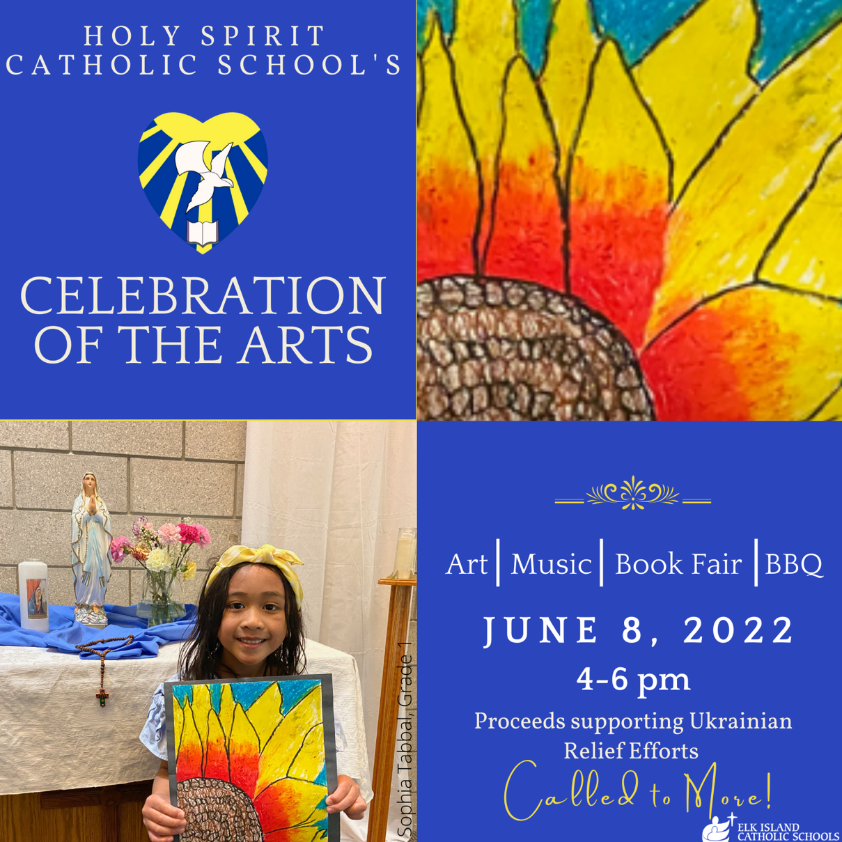
- Curriculum - part of our focus and professional development opportunities for teachers has begun for next year as we navigate the new curriculum
- Swimming as part of the curriculum – Discussion
  - Aoife to check out pricing and fee approval for next meeting
  - Potential ‘referendum’ style request for parents once information in hand
  - Possible grade 3 & 4 only based on change room independence
  - Unisex change rooms potentially allow women volunteers to assist boys

- Adjournment
Jason adjourned the meeting at 7:02pm

